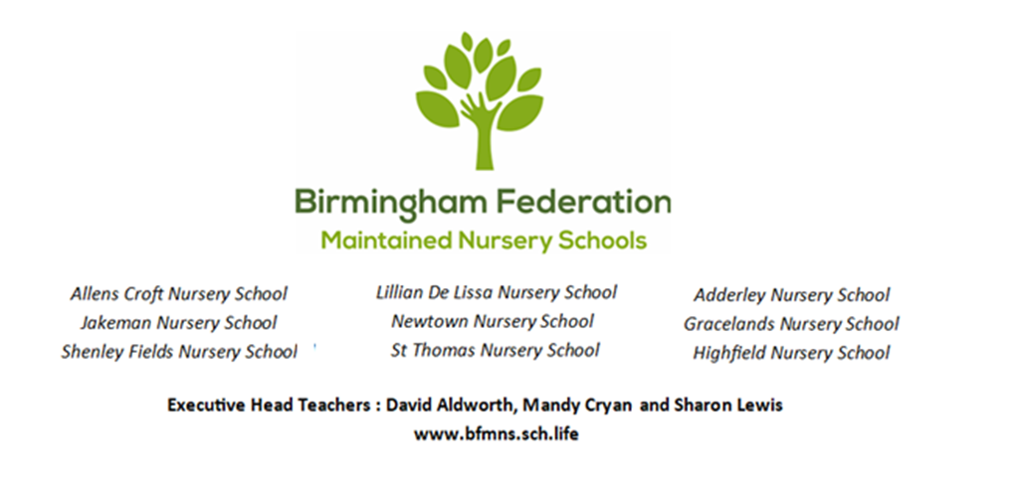

|  |  |  |
| --- | --- | --- |
| *Adderley Nursery School* | *Allens Croft Nursery School* | *Gracelands Nursery School* |
| *Highfield Nursery School* | *Jakeman Nursery School* | *Lillian de Lissa Nursery School* |
| *Newtown Nursery School* | *Shenley Fields Nursery School* | *St Thomas Centre Nursery School* |

**LOOKED AFTER CHILDREN (LAC) AND PREVIOUSLY LOOKED AFTER CHILDREN (PLAC) POLICY**

Full Governing Body Approved: 07 April 2025

Date for renewal: Spring 2027

Chair of Governors: Sean Delaney

Contents

**Statement of Intent** 2

**Legislation and Guidance** 3

**Designated teachers for LAC and PLAC** 3

**Roles and Responsibilities of the Designated Teacher** 3

**Roles and Responsibilities of all staff** 4

**Training** 4

**Pupil Premium Plus (PP+) (February 2018 onwards)** 4

**Transfer out of care** 5

This policy is in accordance with the 1989 United Nations Convention on the Rights of the Child (UNCRC).

***Article 2*** *(non-discrimination) The Convention applies to every child without discrimination, whatever their ethnicity, sex, religion, language, abilities or any other status, whatever they think or say, whatever their family background.*

***Article 3*** *(best interests of the child) The best interests of the child must be a top priority in all decisions and actions that affect children.*

***Article 5*** *(parental guidance and a child’s evolving capacities) Governments must respect the rights and responsibilities of parents and carers to provide guidance and direction to their child as they grow up, so that they fully enjoy their rights. This must be done in a way that recognises the child’s increasing capacity to make their own choices.*

***Article 12*** *(respect for the views of the child) Every child has the right to express their views, feelings and wishes in all matters affecting them, and to have their views considered and taken seriously. This right applies at all times, for example during immigration proceedings, housing decisions or the child’s day-to-day home life.*

***Article 15*** *(freedom of association) Every child has the right to meet with other children and to join groups and organisations, as long as this does not stop other people from enjoying their rights.*

***Article 16*** *(right to privacy) Every child has the right to privacy. The law should protect the child’s private, family and home life, including protecting children from unlawful attacks that harm their reputation.*

***Article 19*** *(protection from violence, abuse and neglect) Governments must do all they can to ensure that children are protected from all forms of violence, abuse, neglect and bad treatment by their parents or anyone else who looks after them.*

***Article 20*** *(children unable to live with their family) If a child cannot be looked after by their immediate family, the government must give them special protection and assistance. This includes making sure the child is provided with alternative care that is continuous and respects the child’s culture, language and religion.*

***Article 21*** *(Adoption)**Children have the right to care and protection if they are adopted or in foster care. The first concern must be what is best for them. The same rules should apply whether they are adopted in the country where they were born, or if they are taken to live in another country.*

***Article 25*** *(review of treatment in care) If a child has been placed away from home for the purpose of care or protection (for example, with a foster family or in hospital), they have the right to a regular review of their treatment, the way they are cared for and their wider circumstances.*

***Article 28*** *(right to education) Every child has the right to an education. Primary education must be free and different forms of secondary education must be available to every child. Discipline in schools must respect children’s dignity and their rights. Richer countries must help poorer countries achieve this.*

***Article 29*** *(goals of education) Education must develop every child’s personality, talents and abilities to the full. It must encourage the child’s respect for human rights, as well as respect for their parents, their own and other cultures, and the environment.*

***Article 39*** *(recovery from trauma and reintegration) Children who have experienced neglect, abuse, exploitation, torture or who are victims of war must receive special support to help them recover their health, dignity, self-respect and social life.*

### **Statement of Intent**

This policy is for the purpose of promoting both the education and the health and well-being of looked after children (LAC) and previously looked after children (PLAC).

### **Legislation and Guidance**

The Children and Social Work Act 2017 established 7 corporate parenting principles which must be applied:

* To act in the best interest and promote the physical and mental health and well-being of children.
* To encourage children to express their views, wishes and feelings.
* To take into account the views, wishes and feelings of children.
* To help children gain access to and make the best use of services provided by the local authority and its relevant partners
* To promote high aspirations and seek to secure the best outcomes for children.
* For children to be safe and for stability in their home lives, relationships and education.
* To prepare those children for adulthood and independent living.

The guidance ‘Promoting the education of looked after children and previously looked after children’ (2018) states the main points:

* Looked-after and previously looked-after children start with the disadvantage of their pre-care experiences and, often, have special educational needs. Virtual School Heads (VSHs) have a key role to ensure these children have the maximum opportunity to reach their full educational potential - an important part of why this role was made statutory.
* For looked-after children, as part of a local authority’s corporate parent role, the Virtual School Head (VSH) needs to be the educational advocate that parents are for others.
* For previously looked-after children, the VSH will be a source of advice and information to help their parents to advocate for them as effectively as possible. VSHs are not acting as part of the corporate parent role in these circumstances, but are there to promote the educational achievement of these children through the provision of advice and information to relevant parties listed in Previously looked after-children.

### **Designated teachers for LAC and PLAC**

The Executive Head Teacher or Head Teacher within each of the Birmingham Federation of Maintained Nursery Schools is committed to ensuring that Designated Teachers and staff are enabled to carry out their responsibilities effectively. Each nursery school has a named Designated Teacher.

The Full Governing Board for the BFMNS has a designated governor for looked after children and previously looked after children.

### **Roles and Responsibilities of the Designated Teacher**

The Designated Teacher should:

* Be an advocate for children in public care
* Has the responsibility to promote the educational achievement of looked after children
* Update Governing Body termly
* When new to either school, ensure a smooth and welcoming induction for the child and carer and note any specific requirements
* Ensure that a Personal Education Plan is completed as soon as possible (within 10 days of their becoming looked after, wherever they are placed). This should be prepared with the child (if appropriate) and the carer, in liaison with the social worker/ LACES and other relevant support workers/agencies, and can be linked to the Care Plan meetings where these are in place.
* Where appropriate, the PEP should take account of any Individual Education Plan (IEP), EHCP, Individual Behaviour Plan (IBP), career plan or any other relevant plans. The PEP should inform and be reviewed concurrently with the Care Plan
* Keep PEPs and other records up to date, particularly in time to inform review meetings
* By the end of the third month in care, ensure baseline assessment form is completed and returned to LACES.
* Ensure that each child in public care has an identified member of staff that they can talk to (this should be based on the child’s wishes and may not necessarily be the Designated Teacher). In Early Years, this is likely to be their key person, however other adults may be chosen.
* Co-ordinate support for the child and liaise with other professionals and carers as necessary
* Ensure staff receive relevant information and training and act as an adviser to staff
* Ensure confidentiality for individual children and only share personal information on a need-to-know basis
* Provide written information to assist planning/review meetings and ensure attendance as far as possible
* Ensure that the child and carer(s) receive early notification of meetings, parents’ evenings and other events and that communication remains regular and positive. The home-school partnership may be adapted to take into account any specific points around communication, transport arrangements and consent signatures
* Encourage children in public care to participate in extra-curricular activities and out of hours learning, where feasible
* Ensure speedy transfer of information between individuals and other relevant agencies and to a new setting if and when the child transfers
* Seek urgent meetings with relevant parties where the child is experiencing difficulties and/or is in danger of being excluded

### **Roles and Responsibilities of all staff**

* Ensure that any child in public care is supported sensitively and that confidentiality is maintained
* Be familiar with the guidance on children in public care and respond appropriately to requests for information to support the completion of PEPs and other documentation needed as part of review meetings
* Respond positively to a child in public care’s request to be the named person that they can talk to when they feel it is necessary
* Contribute to the Designated Teacher’s requests for information on educational attainment and needs as appropriate
* As with all children, ensure that no child in public care is stigmatised in any way
* Provide a supportive climate to enable a child in public care to achieve stability within the setting
* As with all children, have high aspirations for the educational and personal achievement of children in public care
* Positively promote the self-esteem of children in public care

### **Training**

The Executive Head Teacher / Head teacher and / or the Designated Teacher (where not the Executive Head Teacher / Head Teacher) will be responsible for ensuring all staff are briefed on the regulations and practice outlined in this policy.

### **Pupil Premium Plus (PP+) (February 2018 onwards)**

Looked-after children and children adopted from care, on a special guardianship or child arrangements order are eligible for PP+ funding.

This is additional funding provided to help improve the attainment of looked-after and previously looked-after children and close the attainment gap between this group and their peers.

All pupil premium spending should take account of the specific needs of eligible pupils. Whilst there will be some overlap with needs of economically disadvantaged children who attract the pupil premium, looked-after and previously looked-after children’s needs can be very different to others eligible for pupil premium. The extra funding provided by the PP+ reflects the significant additional barriers faced by looked-after and previously looked-after children. The designated teacher has an important role in ensuring the specific needs of looked-after and previously looked-after children are understood by the school’s staff and reflected in how the school uses PP+ to support these children.

For looked-after children, PP+ funding is managed by the Virtual School Head (VSH) for the purpose of supporting their educational achievement. The VSH and schools, including the designated teacher, should work together to agree how this funding can most effectively be used to improve looked-after children’s attainment. All PEPs should include information about how that looked-after child is benefitting from the use of PP+ funding to improve their attainment.

For previously looked-after children, PP+ funding is managed by the child’s school. The amount a school receives is based on the number of eligible children recorded in the school’s annual January School Census return to the Department for Education.

### **Transfer out of care**

When children cease to be looked-after, their educational needs are unlikely to have changed significantly simply because their care status has changed. Although they will no longer be required to have a PEP, designated teachers will wish to consider what is best for continuity and meeting the child’s educational needs. This will particularly apply to those who leave care through adoption, Special Guardianship or a Child Arrangements Order, where the designated teacher has a duty to promote their educational attainment. As part of this, designated teachers should maintain links with VSHs who must make advice and information available to them for the purposes of promoting the educational achievement of this group of previously looked-after children.